Address Book
for WinWord 6.0
Version 4.51

Table of Contents
Introduction
Program Description
FAX Software Users
For International Users
For Hebrew Users
Win95, and WinWord 7.0 Users
What is ShareWare
Registering the program
How to Register
Why to register?
One benefit for registered users
Upgrades Policy
License Agreement
Running and Installing
Before you Install
Manual Install
One word about Back-Up
Run, and Install Buttons
User’s Guide
Read Me First
The Main Dialog
Search Dialog
Search Result Dialog
Edit / New Dialogs
Exchange Dialog
Report List Dialog
Create Labels Dialog
‘User Free Selection’ Export Dialog
File to Import Dialog
Import Dialog
Setup Dialog
Version History
Known Problems
Other Products
New Print Dialog for WinWord 6.0
Reference Database for WinWord 6.0
Free Macros Library for WinWord 6.0
Contacting the author, and technical support
Acknowledgments

Introduction

Program Description
Address Book for WinWord 6.0
Store up to 1000 names, Addresses and phone numbers.
Search for specific record by name or by company.
Insert the details directly to your document. Only the desired details, and exactly the way you want.
Import and Export data.
Create reports. Normal report, and Wide report for mail merge.
Create Labels.
The Address Book sorted automatically after every change made. All the changes will be saved at the end of the session.
Included template for creating letter. You can edit the template, and use it as a sample to create your own templates that take advantage of Address Book.

FAX Software Users
Address Book inserts bookmarks into the document.
If your FAX software supports DDE, then you can take advantage of these bookmarks, and create macro that will send the FAX, while gathering the name and the FAX number from the document.
For more information look in your FAX software manual, or contact the author.

For International Users
The program should work under the German, France, Italian, and all other Non-English versions of WinWord.
See the for more information.

For Hebrew Users
The program supports both English and Hebrew languages.
See the for more information.

Win95, and WinWord 7.0 Users
The program tested with WinWord 6.0 under Win95 with no problems.
As reported by users, the program works OK with WinWord 7.0 too (Under Win95). It was not tested by the author, yet.

What is ShareWare
ShareWare programs are not free. They are given you for trial period, so you can test them in your home or office, on your own machine. You don’t have to buy just on the basis of some demo, or some short demonstration on the computer at store. Yes, that’s right, check it in real life before you buy.
If you find the program useful, and keep using it, after the trial period, then you are expected to register.

Registering the program
You are welcome to try the program, for 30 days.
There are no “Nag Screens” to remind you to register, and there are also no extra features in the registered version, nor any limitations in the shareware one.
The registration fee is $17.00 (50 NIS, in Israel).
As default no disk will be shipped. The registration code will be send via E-Mail, or FAX, if no E-Mail address is available.
However if you do want to get a disk, one will be shipped for additional $3.00 (All over the world)
Site License for 10 users available for $100
Global License for more than 50 users available for $500

How to Register
You can register directly to the author, or via Kagi Shareware registration service.
The author can process Checks, and Cash in $US, and NIS (New Israel Shekel) only.
Kagi Shareware can process Credit-Cards, Money Orders, Invoices, Checks, or Cash in variety of exchangeable currencies
To print an order form double-click the Print Order Form button, bellow, or use the Order Form button in the About dialog of the Address Book.
If the Kagi Shareware option in the Order Form dialog disabled, you should use the Register program bundled in the ZIP file. Extract the files REGISTER.EXE, and REGISTER.HLP to the same directory, and run the Register program.
When you register via Kagi Shareware company they will process the registration, and will send the author a note about your registration. The author will send you the registration code (Or the Disk, if the $3 Disk part in the program will be set) when he will be notified by Kagi Shareware that they processed your order.
You are advised to send a copy of your registration form to the author.

Why to register?
A lot of people ask “why to register shareware programs, when I can use them free off charge?” There are few answers to that question:
- When you register you support the ShareWare concept. ShareWare authors don’t spend money for advertising and fancy offices, that’s why you can get good products for fair price.
- ShareWare authors spend a lot of time trying to give you the best product, bugs free. Only registering the programs will allow them to keep doing this.
- Hi, I almost forgot, don’t you think you should pay for something that you find useful, and use with? And have some peace of mind doing so?

One benefit for registered users
If you use other PIM, and you would like to have an Import/Export routine for that PIM, send the author an E-Mail message, and specify the exact structure of the file. (Number of fields, Data in each field, Delimiter) Also specify if there is an INI file with the location, and the length of the data file. In that INI file specify the section and the lines with the relevant data.
Import/Export routines can be made to text data file only.
The requested Import/Export routine will be added to future version.
For example:
In the file TALFUCHS.INI
[Address Book for WinWord]
AddressBook=
NoOfRecords=

Data file structure
“Name”,”Title”,”Company”,”Phone”,”FAX”

Upgrades Policy
Registered users can upgrade all minor versions free of charge, when downloading the file from any BBS or other on-line service, and by using the same registration details.
The price for major version upgrade is $12. ($70 for 10 users, $350 for more than 50 users)
The price for minor version upgrade via post is the same as for major version upgrade+shiping ($15)

For limited time (June 31) registered users of previous versions can get free upgrade, via E-Mail (Or FAX, if no E-Mail address is available).
Contact the author to get your registration code.

License Agreement
- The license is granted on a per user basis. This includes the right to install and use the software on one or more computers so long as the total number of users does not exceed the license quantity.
- Permission is hereby granted for any SysOp or other person in charge of maintaining on-line services to offer a copy of the Address Book for downloading, as long as no charge other than normal charges for system access are made, and as long as the originally distributed files are kept together and offered in unmodified form.
- The Address Book is distributed as is, with no warranty regarding its usefulness or fitness for any particular purpose. While care has been taken to produce software which is problem free, the author assumes no responsibility or liability for any failure of this software, or any problems, or damage ensuing thereby.
- Any use of the software is construed as acceptance of this disclaimer of liability
- The Address Book may not be distributed with any commercial software product without the prior, express, written permission of the author.

Running and Installing
- To run the program double-click the Run Address Book button.
- To install the program to your global template, so it will be available whenever you use WinWord, double-click the Install Address Book button. The Address book will be installed at the end of your Tools Menu, as Address Book.

Before you Install
- If you have an earlier version of the program the install routine will convert your old Address Book data file to the new version.
You are advised to make a back-up copy to your data file (ABOOK.DAT, in your WinWord directory)
- The current version will save the data in the file ABOOK.DAT in your WinWord directory.
- The old Address Book data will be saved as ABOOK.OLD
- The setting will be saved in the file TALFUCHS.INI in your Windows directory. No more WIN.INI mess.
- You can remove the [WinWord Address Book] section from your WIN.INI file, which is located in your Windows directory
- There is currently no automatic uninstall routine. So if you don’t want to use the program you’ll have to uninstall it yourself. I hope I’ll can manage uninstall routine in the future.
- The Setting are saved in your Windows directory in the file TALFUCHS.INI
- The Address Book file saved in your WinWord directory, as ABOOK.DAT.
- To remove the macros use the Tools/Macro command.
- To remove the changes made to the menu use the Tools/Customize/Menus command.

Manual Install
If the Install routine fails than you can install the Address Book manually.
- Use Tools/Macro/Organizer to copy the ABook macro from that file into your GLOBAL template (Usually NORMAL.DOT template.)
- Rename the macro to AddressBook.
- Use Tools/Macro/Organizer to copy TalFuchsLib, TalFuchsExport, and TalFuchsImport macros from that file into your GLOBAL template (Usually NORMAL.DOT template.). If the macros are already on your system then make sure to keep the newer ones on your GLOBAL template.
- Use Tools/Customize/Menus to add the AddressBook to the end of your Tools menu.
Please note that if you installed the program manually, and you have an earlier version of the program you may have to edit the Address Book file manually to fit it to the current version.
If you have a back up copy of the data you can use the Import routine to get it into the Address Book data.

One word about Back-Up
Back-up Back-up Back-up Back-up .....
It will never be too much to say about back-up.
A routine to back-up the Address Book data added to the end of the session.

Run, and Install Buttons

User’s Guide

Read Me First

This User’s Guide is a Hyper Link document.
Whenever you see a green text you can double-click on it to jump to the relevant place in the document.

The Main Dialog

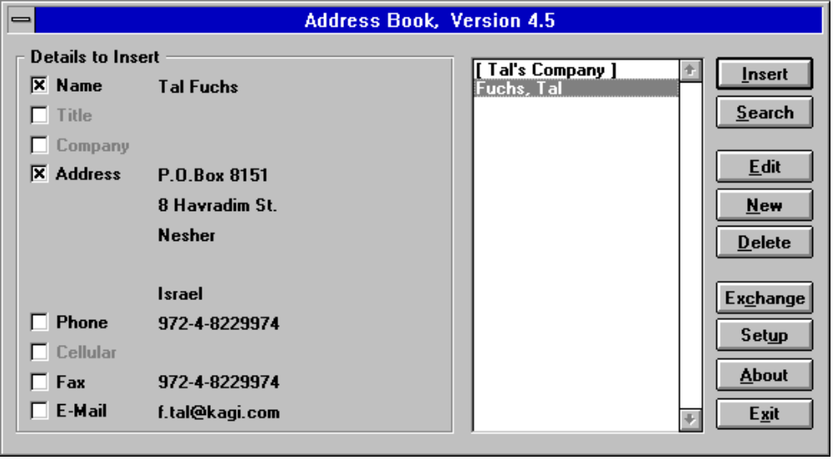

List of Names and Companies
Shows the list of names and/or Companies in the Address Book.
Select the desired name (Or Company) to insert its details to the document.
See “” for instructions how to show companies, as default.
Name will be shown, in the list, as “LastName, FirstName”.
Companies will always be shown inside brackets, and will be shown at the beginning of the list.
If the default field to show (Name or Company) is empty, then the other one will be shown instead.

Details to Insert
Select the desired details to insert to your document. Only the selected ones will be inserted.
See “” for instructions how to select the default details that will be selected.
See “” for instructions how to change the appearance of the Name field.

Insert
Inserts the selected details to the document

Search
Search for specific name and/or company.
See “” for more information.

Edit
Edit the selected record.
See “” for more information.

New
Create new record in the Address Book.
See “” for more information.

Delete
Delete the selected record from the Address Book. You will be asked for confirmation.

Exchange
Report, Export, and Import
Create a report of the Address Book.
- Normal Report
- Wide Report for Mail Merge
- Labels
Export the data to text file that can be imported into other PIMs.
Import data from other files.
See “” for more information.

Setup
Change various settings in Address Book.
See “” for more information.

About
Display the About dialog.
Show the registration information.
Use Register to insert your registration details, after having the registration code.
Use Print Order Form, to create registration form, for Address Book, and other programs.

Exit
Exit the program, and save all changes made to the data.

Search Dialog

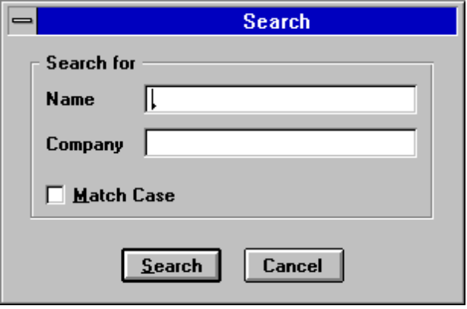

Type the Name or the Company to search for.
If you type Name and Company then the search will be exclusively for those records matches both Name and Company. (AND Search)

Search Result Dialog

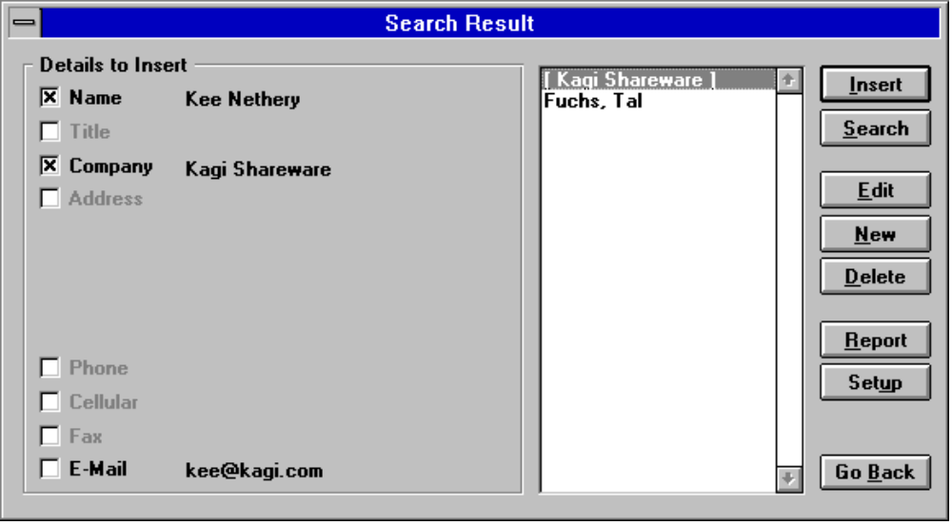

Show the result of the Search routine.

Report
Create Reports based on the search result.
The “” won’t be shown.

Go Back
Go back to the .
The selected record will remain selected.

Edit / New Dialogs

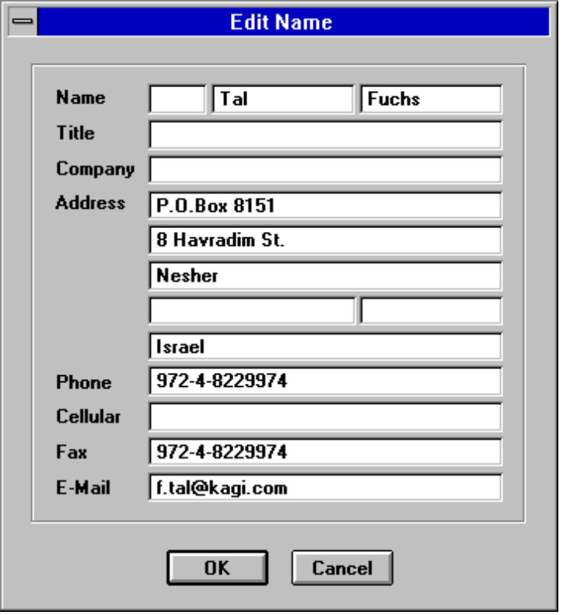

Edit the details for the selected record.
In the name line there are three fields:
- Salutation
- First Name
- Last Name
Use the ‘’ to choose how these fields will be inserted into the document.
In the 4th. Address line there are two fields:
- Address4
- Zip/Postal Code.
They will be inserted to the document on the same line. Zip/Postal Code will be inserted to the document only if ‘Address4’ field is not empty.

Exchange Dialog

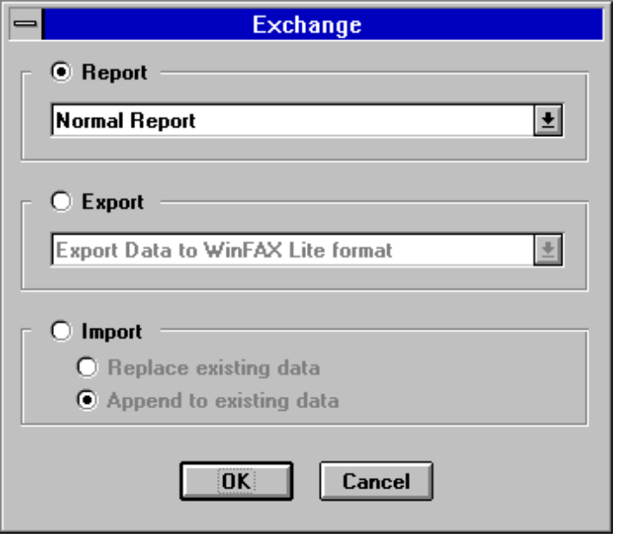

Report
Choose Report, and the style of report, to create report of the Address Book.
Report can be done in three ways:
- Normal Report.
- Wide Report that will be used for Mail-Merge.
- Create Labels.
In the next dialog (See ) you will choose which record will be in the report. You can select all the records, or individual ones.
Report won’t be available if the Address Book data is empty

Export
Choose Export to create text file than can be imported into other PIM or Communication programs.
There are currently two programs supported:
- WinFAX Lite, Version 3.0
- ProComm+, Version 2.0
There is also an option for ‘’.
See the ‘’ for more information.
You will get instructions in the Export routine how to import the data into your program. Look in your program USER’S GUIDE for more information
Export won’t be available if the Address Book data is empty

Import
Import data from other text files.
Replace existing data in Address Book data file, or append data to existing data.
Import won’t be available if there are 1000 records in the Address Book data.

Report List Dialog

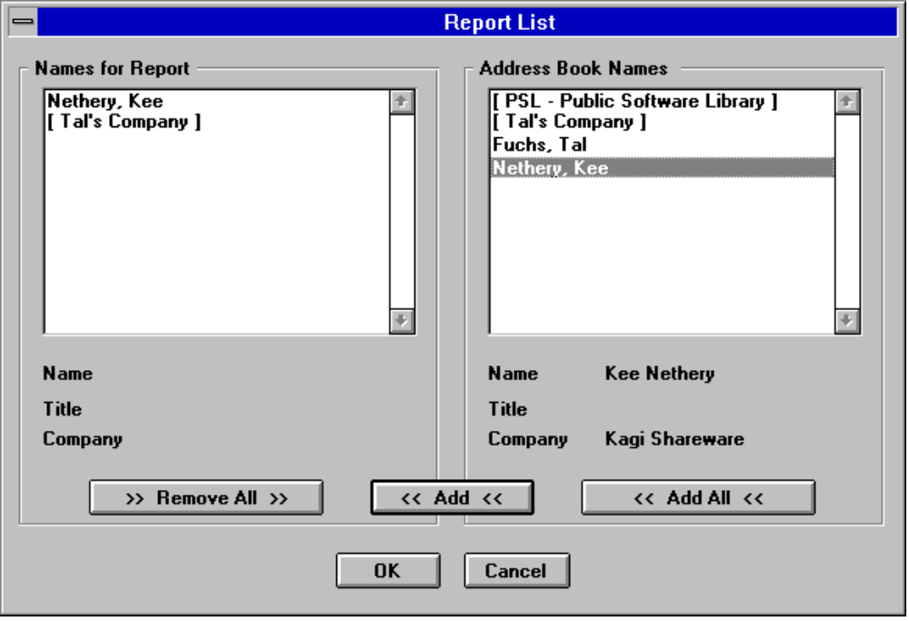

In the Report List dialog you choose which records will be in the report.
This dialog won’t be shown if you create Report based on the .

Add All
Choose the Add All button to put all records in the report.

Add
Choose the Add button (Or double-click on a name) to add the selected record to the report list.
You can’t add the same record twice.

Remove All
Remove All records from the ‘Name to Report’ list.

How to remove a single name?
Selecting a name in the Names for Report list (If the list is not empty) will cause the Add button to Change into Remove one.
You can remove records from the Report List, by choosing the Remove Button (Or double-click on a name).

Create Labels Dialog

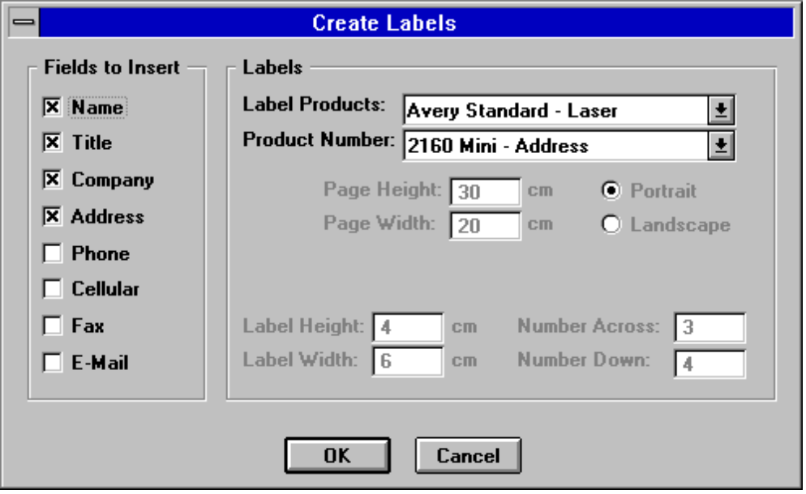

Label Products
Select the desired label products.

Product Number
Select the product number of your labels.

User Customized Labels
In the ‘Labels Products’ choose the ‘USER CUSTOM LABELS’.
The ‘Product Number’ drop down list will turn into ‘Page Size’ list.
Select the desired page size, the Size of the labels, and the number of labels on page. To set the Page Size manually choose the ‘USER CUSTOM PAGE SIZE’ from the list.
The data you set will be saved as the default Label Product, Product Number, Page Size, and format of labels.

‘User Free Selection’ Export Dialog

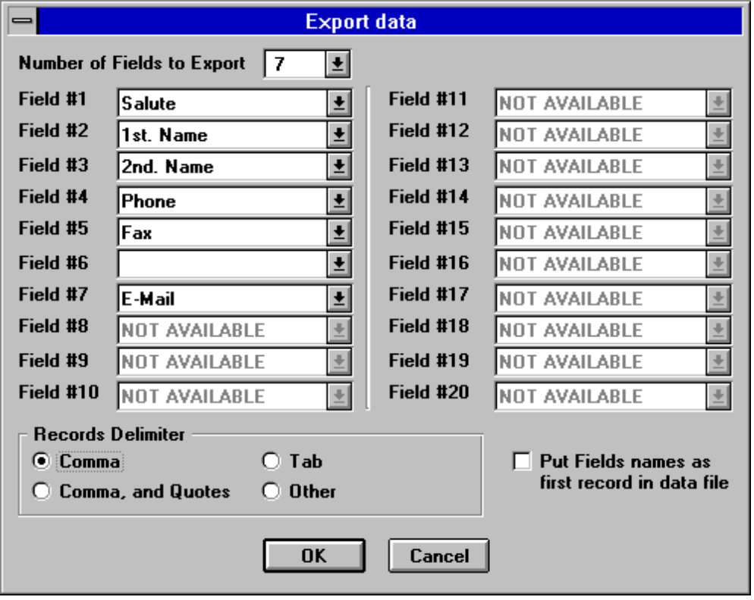

Number of Fields to Export
Select the number of fields you want to export.
You won’t be able to specify the data for the fields until you specify the number of fields you want to export.

Filed #
Specify the data you want to put in each field.
Leave empty or select ‘NONE OF THE ABOVE’ to export this field as an empty one.

Records Delimiter
Specify the Records Delimiter.

Put Fields names as first record
Select this check box to put the field names as the first record in the exported data file. This can make importing the data into other applications much easier.

File to Import Dialog

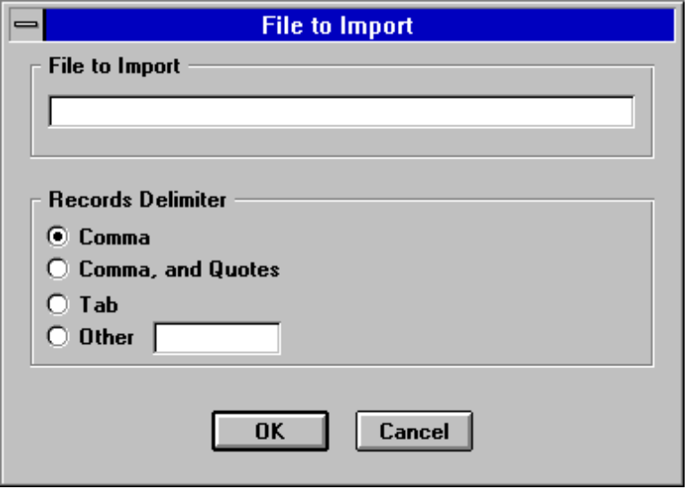

File to Import
Write the file name that you want to import data from.
In case the file does not exist, or has no data in it, you will get an error message.

Records Delimiter
Specify the delimiter between the records in your data file.
If the delimiter you specified will not be found in the first line of the data file you will get an error message.

Import Dialog

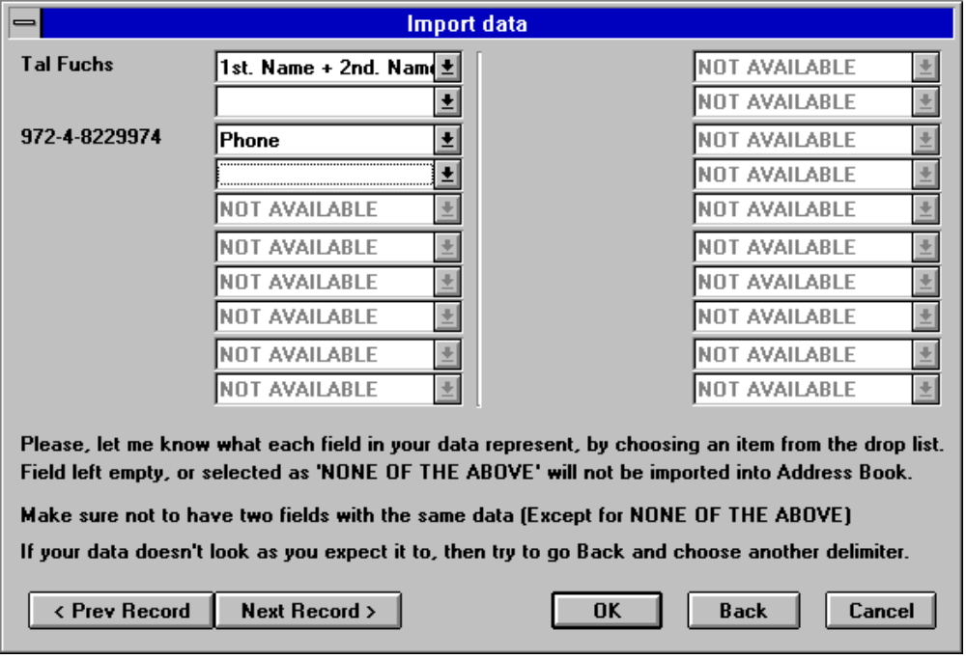

In the Import dialog you should specify the type of data that appear in each field of your data file. Choose the appropriate field name from the drop down list.
Make sure not to assign the same field name to more than one field (Except for leaving empty or choosing ‘NON OF THE ABOVE’)

Prev Record / Next Record
By using the ‘Prev Record’ and ‘Next Record’ buttons you can move between the records in your data.

Go Back
If your records do not look the way you expect them too, it’s probably because you specified wrong delimiter. Try to go Back and choose another delimiter.
You can use the ‘Go Back’ to select another file to import from.

Import Tips
It is recommended to create the first record, in your application, so it will include the names of the fields. This will make identification of the fields, while importing, much easier.

Setup Dialog

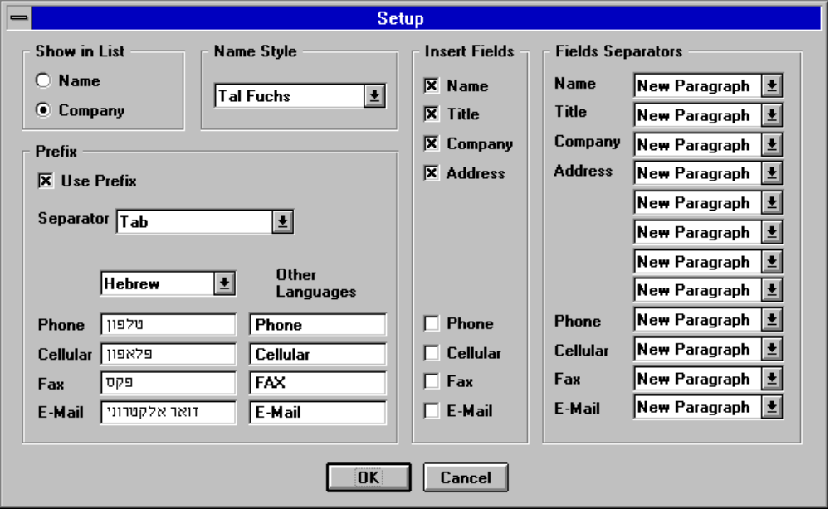

Show in List
Select what to show (As default) in the list of the , and the of Address Book:
- Names
- Companies
If the default field to show (Name or Company) is empty, then the other one will be shown instead.
Companies will always be shown inside brackets, and will be shown at the beginning of the list.

Name Style
Change the style of the Name field.
- Mr. Fuchs
- Mr. Tal Fuchs
- Tal Fuchs
- Tal
The name will be inserted into the document in the selected style.
The name will be shown this way in the , and the of Address Book:

Prefix
Choose if to insert prefixes for Phone, Cellular, FAX, and E-Mail.
If you choose to insert prefixes then you can decide how they will look like, by writing the prefix you desire for each one of them, and selecting the desired separator between the prefix and the number itself.
You can set specific prefixes for specific language. This is most useful for users of Non-English version of WinWord. These prefixes will be used whenever the language of the document is the one chosen in the ‘Language’ drop down list. The prefixes in the ‘Other Languages’ part will be used in all other cases.
If you use only one language all the time you can safely ignore the settings for the specific language, and keep only the prefixes in the ‘Other Languages’ part.

Fields to Insert
Select the default fields that will be selected, in the , the , and the

Fields Separators
Select the separator that you want to have after each field.
For examples:
- If you want to have the Name and the Title on the same line then choose the Field Separator for name to be “Comma and Space”
- If you want to have all the Addresses fields in one paragraph, but different lines (So you can format them as one paragraph) then choose the Field Separators for Address1, Address2, Address3, and Address4 to be “New Line”

For Advanced users All these settings are saved as plain text in the TALFUCHS.INI file, and you can change them in your templates, without using the Setup dialog.
For example: to change the Show in List to Name, use the following command in your macro:
SetPrivateProfileString "WinWord Address Book", "Show", “0”, "talfuchs.ini"

Version History

Version 4.51
- Fixed some bugs.
- Better error handling to find bugs (Hope not).

Version 4.5
- Most functions can be done directly from the .
- ‘Create Labels’ added to the list of Report options, in the .
- Added an option to put the Fields Names as the first record while exporting data, in the ‘’.
- changed to fit users of Non-English versions of WInWord.
- Some bugs while using Non-English versions of WinWord fixed.
- The Register application will be installed for easier registration using Kagi Shareware registration service.
- A routine to back-up the Address Book data added to the end of the session.

Version 4.4
- The program should work under the German, France, Italian, and all other Non-English versions of WinWord.
- ‘ESC’ key can be used as ‘Cancel’, and as ‘Exit’.

Version 4.3
- Added 5th. line to the address. The 5th. line is for ‘State’.
While installing, the 4th. line will be move to the 5th. one.
- Line 4 splited into two fields: Address 4, and Zip/Postal Code. They will be inserted to the document on the same line.
- Added ‘Space’ to the Fields Separators drop list in the Setup dialog.
- Added ‘User Free Selection’ option to the Export routine.
In this option you should specify the number of fields to export, the data to put in each field, and the records delimiter.
- Included template for sending FAX, using WinFax. (You can modify it to work with other FAX software)
- Fixed bug in the Import routine.

Version 4.2
- Report button renamed to Exchange (Location changed too)
Exchange has three options: Report, Export, and Import.
- Loading and saving the data file made much faster.
About 1/2 the time if they where no quotes in data, and about 1/4 if they where a lot of quotes in data.
- Quotes are saved in the data file as two apostrophes (This made the data loading and saving faster).
Version 4.1
- Added Report List dialog.
This dialog appears when you create report. In the dialog you can select which records will be in the report, all records, or individual ones.
- Fixed bug that caused Error No. 9, when the Address Book had no records.

Version 4.0
- Since new method has been taken, Address Book is limited to 1000 records now, but adding, editing, and deleting records are about 10 times faster.
- The List can show (As default) Names or Companies.
- BookMark will be inserted with any field that is inserted to the document so users of WinFAX can create macros to automate FAX sending.
- Report has now two options:
Report, and Export. Export will export the data file to files format that can be imported into others PIM (WinFAX Lite, and ProComm+)
- Report style removed from the Setup dialog. In the report dialog you can choose the records to report.
- Added macro TalFuchsExport, that include the Export Formats.

Version 3.63
- Fixed bug in copying TalFuchsLib macro, during install routine.

Version 3.6
- Fixed bug in converting old database, during install routine.

Version 3.5
- Title and Cellular fields added to data file.
- Name is in two fields now. First Name, and Last Name. The install routine will split old names fields to the new ones.

Version 3.4
- Search routine made faster.
- Order Form changed, so registering more than one program is easier. By doing so you can cut the shipping and handling costs.

Version 3.3
- Name can be left blank. In that case Company will be shown in the list, inside brackets. That’s way all companies will be seen at the beginning of the list.
- Fixed bug caused error No. 9 while there are no records in Address Book.

Version 3.2
- Selecting details to insert will be sticky.
- Address Book won’t run if there is no open file, nor in the macro editing window.
- Shared macro lib TalFuchsLib changed to fit others' programs too.

Version 3.1
- Fixed bug in setting number of records in INI file.
- Set the default fields to be inserted to document (The fields that will be checked in the main dialog, and in the search result dialog)
- Part of the code removed to the TalFuchsLib macro. This is shared lib for all future products.

Version 3.0
- Data File format has been changed. Quotes instead of Commas are saved as ‘~~’ This make data retrieval much faster.
- Setup option let you decide exactly how the data will be inserted to your document.
- Main dialog interface changed a little.
- Report can be done as Normal Report, or as Wide Report for using in Mail Merge.

Version 2.4
- The main Address Book dialog made wider, for low resolution (VGA) too.
- Large parts of the code were rewritten to gain some performance improvement.
- Much better Errors handling.

Version 2.3
- Report button added. It will create hard copy of the Address Book.
- Salutation field added.

Version 2.2
- Fixed bug in the search routine
- Made little bit faster

Version 2.1
- Copy command renamed to Insert command.
- Edit and New dialogs made wider, so more information can be seen.
- Sort routine made faster, especially in the New-Name subroutine.
- Changes made in the Run Address Book routine will be saved.
- If the screen resolution is 800*600 or higher than the main Address Book dialog will be wider, so more information can be seen, in the details' part of the dialog.
- Using commas that made troubles, is no longer problem. Commas can be used freely in the Address Book.

Version 2.0
- First WinWord 6.0 version.
- Versions' 1.x are for WinWord 2.0

Known Problems
- Using ‘&’ in the Address Book will be seen as ‘_’ , but it will be inserted correctly as ‘&’ into the document.
- Quotes are saved in the ABOOK.DAT file as two apostrophes (This made the data loading and saving faster).
Since, to my knowledge, Quotes used for Addresses in Hebrew only, it won’t bother most users.

Other Products

New Print Dialog for WinWord 6.0
New Print Dialog replaces WinWord default print dialog.
If you have more than one printer attached to your system, then this program is must have one. Printer selection made much easier, directly from the dialog. (Up to 16 printers.)
If you, more than once, wanted to print a document, but it was send to the FAX instead, then this program will make sure it won’t ever happen again. The default printer will be restored after the print job ends.
Changing various settings like Reverse Print Order, and Draft Output done in the dialog itself, without going to the Print Options.

Reference Database for WinWord 6.0
Store up to 1000 References.
Work on up to 5 projects at the same time.
Choose the desired project.
Rename a project to delete it’s data.
Search for specific reference by name or by title.
Insert the Name(s), and Year details to your document.
Create reports for the projects you are working on, or any other project.
The Reference Database sorted automatically after every change made. All the changes will be saved at the end of the session.

Free Macros Library for WinWord 6.0
The library contains WinWord macros that can be used freely, with no charge, you can edit them as you like, and make any use of them, in your programs.

Contacting the author, and technical support
Please send inquiries, comments, or fees to the author at the address below.
Technical support available for registered and unregistered users, via E-Mail or via the post office.

Tal Fuchs

P.O. Box 8151
8 Havradim St.
Nesher
Israel

Phone: 972-4-8229974
E-Mail: f.tal@kagi.com
http://www.kagi.com/authors/f.tal/

Acknowledgments
- All registered users that support the program, and the shareware concept.
- All registered and unregistered users who send bugs reports, and by doing so helping me make the program bug free.
- All the users who keep sending comments and suggestions, to make this program better one.
- Special thanks to wolfgang Holdinghausen (Germany) for his ideas, and tips, and especially for testing the program under the German version of WinWord.

